TEACHERS @ UCAN2 DANCE STUDIO
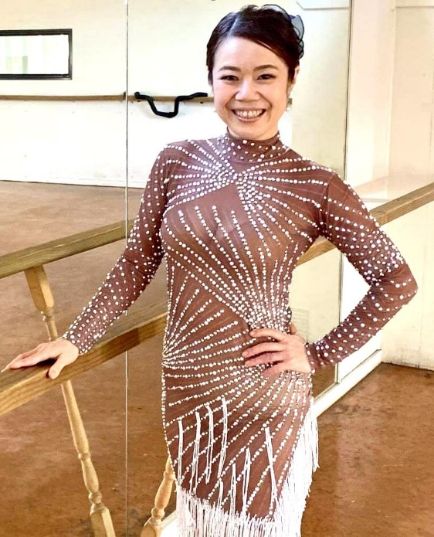
MAI DAHLBERG
I specialise in Ballroom Standard and Latin American - 10 dances, as well as various Street Latin dances: Salsa (on "1" and on "2"), NY Mambo, Cuban Salsa, Bachata, Merengue, Argentine Tango and Brazilian Samba. I also teach Latin Ladies Styling, Burlesque and Chair dance.
I have won numerous titles at Salsa Championships in New Zealand and Australia. I am very experienced in various performances internationally. I have also coached several competitive winning Salsa & Bachata teams.
Choreography is one of my specialties. I love being creative! Be it your Wedding Dance or Show Performance, I have a variety of dance experience and knowledge to come up with authentic ideas to fuse smoothly into something unique.
I passionately coach my students at all levels to achieve their goals.
Availability:
Monday to Friday 9am-9pm
Saturday 10am-2pm
Sunday 6pm to 9pm
[Annual Leave: 14-28th of January 2024. Please contact Marie on 021767997 for urgent communication]
Please contact me to get started on 0210445933.
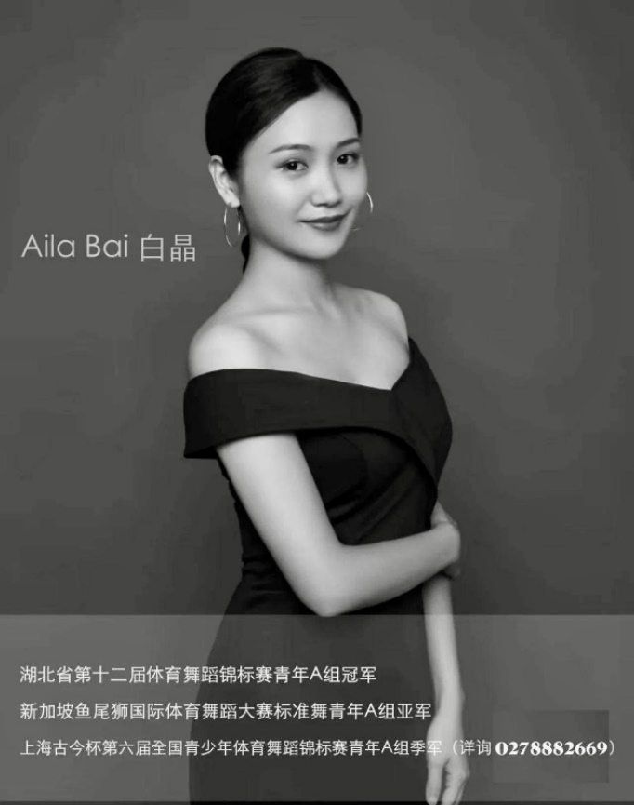
AILA (JING) BAI
我是主讲老师Aila，为中国体育舞蹈联合会国家一级教师，国家级裁判员，我是一直坚持在教学一线，竞技比赛一线，亲自授课，用心教好每一位学生，用培养专业选手的方法教授业余学子拉丁和摩登技能是我孜孜不倦的追求！我还能专门为您的婚礼创作美丽的第一支舞，并且我在表演舞蹈编舞方面也非常有经验。请通过0228882669与我联系。
I am Aila, UCan2 Dance Studio's Mandarin-speaking teacher. I am a national first-class teacher of the China Dancesport Federation and a national referee. I am currently a registered professional dancer in New Zealand. I am an experienced 10-dance teacher specialising in both Ballroom Standard and Latin American dances. I also specialise in creating beautiful First Dances for your Wedding and am very experienced in choregraphing for Show Dances.
I have always believed in teaching all my students like teaching my professional competitive couples. I insist on in-person, hands-on style of teaching. I will tirelessly demonstrate whole-heartedly and ensure your lesson with me is a productive, meaningful and an enjoyable one. I guarantee you professionalism and passion from me in every one of my classes.
Availability:
Monday to Friday: 9am-9pm
Saturday & Sunday: by appointments
Please contact me on 0228882669.

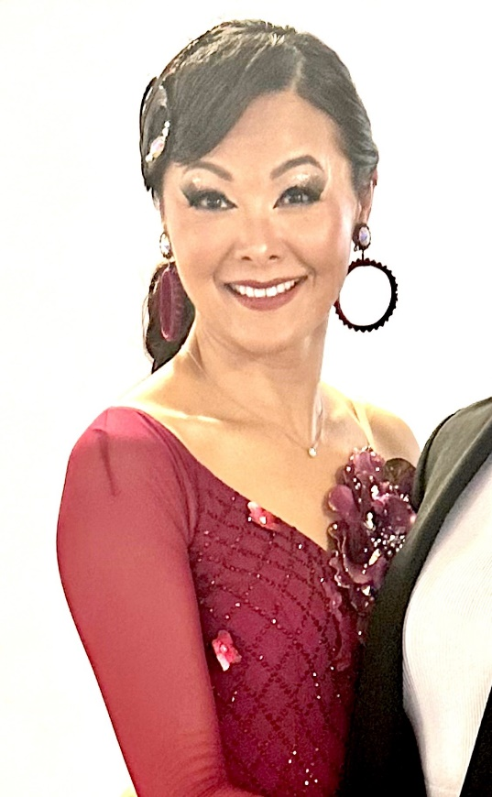
CHIA-I LIU
"Dancing is the joy of movement and heart of life. It is the hidden language of soul (M. Graham)"
My passion is to bring joy to you through dancing and share my dance knowledge with you.
I dance and teach International Ballroom Standard (Waltz, Tango, Viennese Waltz, Slow Foxtrot and Quickstep) and Latin American (Samba, Cha Cha Cha, Rumba, Paso Doble and Jive) dances.
I am always available to prepare you and partner you at your Competitions and Medal Tests. My newly added repertoire is to choreograph and teach Wedding Dances, your First Dance is my priority!
Availability:
Monday to Saturday 12pm-6pm
Please contact me directly on 021773678 to confirm our lesson.

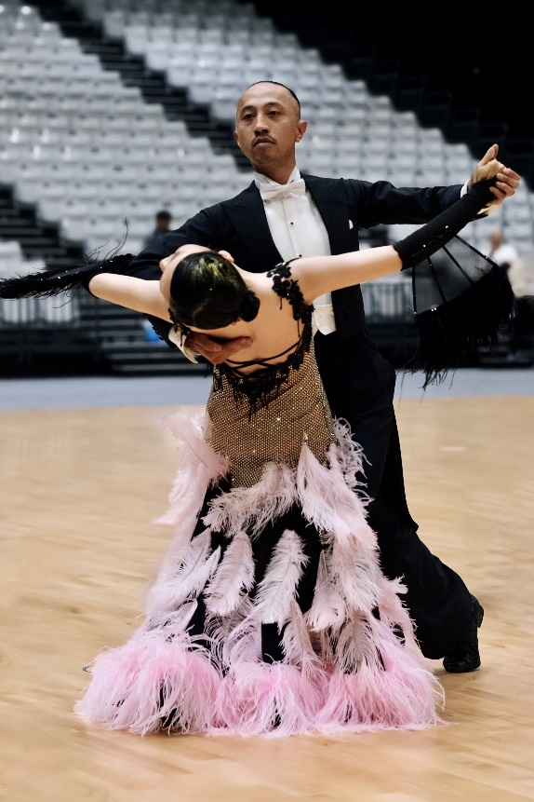
CARLO RAMOS
Dancing is life!
I started dancing when I was 8 years old. I have an extensive experience as a competitive dancer in International Ballroom Standard (Waltz, Tango, Viennese Waltz, Slow Foxtrot and Quickstep) and Latin American dances. I am currently a registered professional 10-dance dancer.
At UCan2 Dance Studio, I teacher the Adult & Youth Social Dance courses, Bronze Medal course and Wedding Dance Lessons. I am love to teach and choreograph all other dance styles: Contemporary, Hip Hop, Jazz, Modern Dance...etc.
Contact me and let me share this passion for dancing with you!
Availability:
TBC
Please contact me on 0210345279.

